DMA SEIC
Department of Military Affairs
State Equity & Inclusion Committee
Membership and Resource Directory
2022-2024

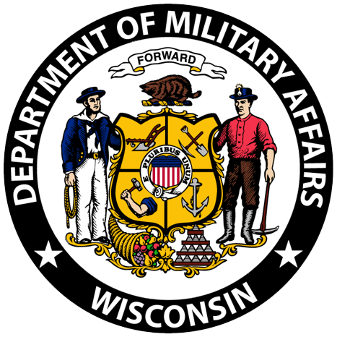
DMA SEIC

Department of Military Affairs State Equity and Inclusion Committee
In this document you will find names, phone numbers and email addresses for the DMA SEIC members who you can reach out to with questions, concerns or to get additional information.

Also included are resources available to you to assist with diversity, inclusion and other issues you may experience in the workplace or at home.

This group provides support to State DMA employees from Security, REACT, WEM, CFMO, Challenge Academy and various other locations across the State.

You can reach the membership by emailing - DMASEIC@widma.gov

The purpose of the DMA DEIC

- To advise and recommend equity and inclusion policy and rules to TAG (The Adjutant General), through the State EI (Equity and Inclusion) Officer at DMA.

- Provide training and educational resources to fellow employees on equity and inclusion as well as accessibility and diversity topics.

- To investigate activities for discriminatory practices as necessary.

- Serve as a Liaison to employees and supervisors regarding potential violations of the Respectful Workplace policy and offer support.

DMA SEIC Membership & Resource Directory
 | 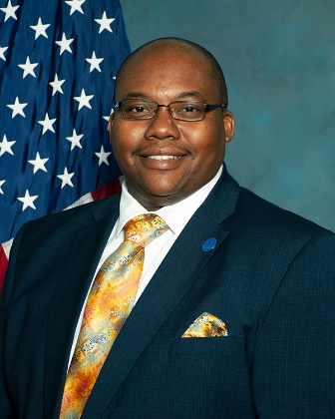
Shawn Sallee - Chair
DMA Security
Milwaukee
Shawn.sallee@wisconsin.gov
414-400-3479

Dorothy Bristor – Vice Chair
Staff Development Program Specialist Sr
REACT/Camp Douglas/Volk
Dorothy.bristor@widma.gov | 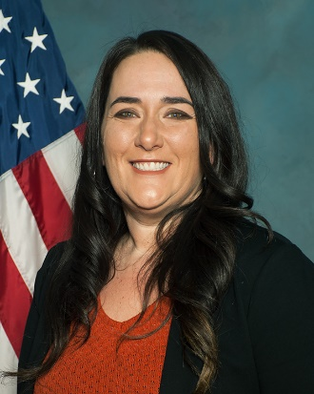
608-316-5042

Teresa Erler – Secretary/Treasurer
NE Region Director – Field Services | 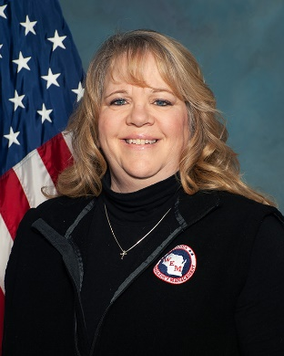
WEM - Wausau
Teresa.erler@widma.gov
608-286-0225

Rob Thiede
CFMO Area 6 Facilities Repair – Adv
Southeast | 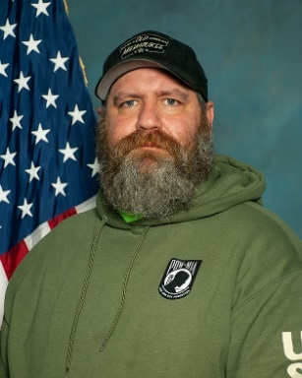
Robert.thiede@widma.gov

608-440-0463

Joseph Grenier
Security Supervisor | 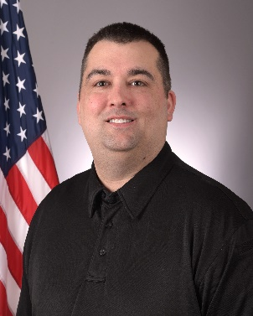
TRUAX
Joseph.grenier@us.af.mil

608-245-4331
Andrew (Drew) Paulsen
Challenge Academy
Fort McCoy
Andrew.paulsen@wisconsin.gov | 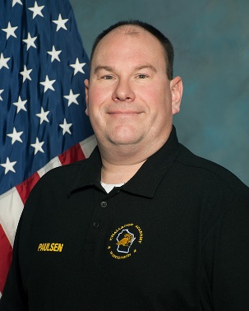
608-343-1951

Lacey Donatell
WEM Office Operations Associate | 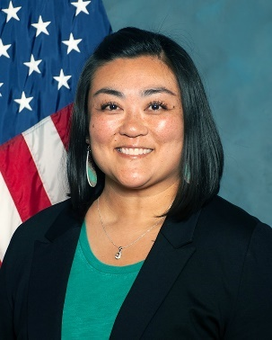
Northwest, West Central, Southwest
Lacey.donatell@widma.gov

715-839-3826 or 608-630-3572

Sam Liebl
Lead Recovery Planner
WEM HQ
Samantha.liebl@widma.gov  608-316-5374 | 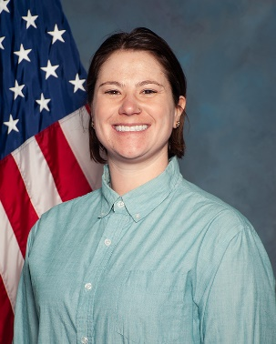
DMA SEIC | Membership & Resource Directory
Jennifer Caravella
Real Estate Specialist | 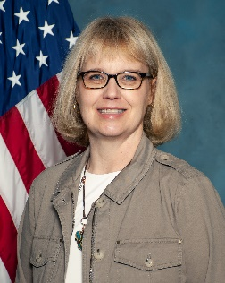
JFHQ CFMO
Jennifer.caravella@widma.gov
608-242-3357 or 608-369-1808
Stacie Meyer – ExOfficio
State HR Director – EI Officer
JFHQ - Madison
Stacie.meyer@widma.gov | 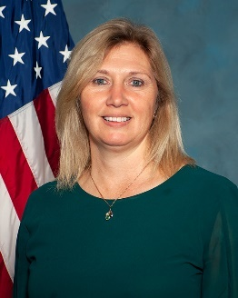
608-242-3163

Jayne Swingen – ExOfficio
Deputy HR Director
JFHQ – Madison | 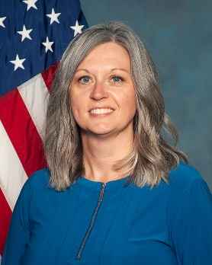
Jayne.swingen@widma.gov
608-242-3157

Katie Bermudez - ExOfficio
Diversity & Inclusion Program Manager
WING
Kathrine.a.bermudez@army.mil  608-242-3747 | 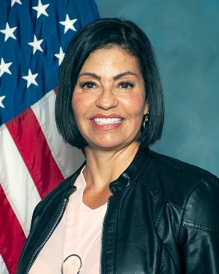
DMA SEIC | Membership & Resource Directory

DMA SEIC | Membership & Resource Directory

State Employee Assistance Program (EAP)

The Employee Assistance Program (EAP) provides State of Wisconsin employees and their household family members free and confidential support 24 hours a day, seven days a week for a variety of issues – ranging from everyday matters to more serious concerns including:
- Work-life stresses
- Anxiety, depression, or other mood disorders
- Relationship or other family problems, including divorce and abuse
- Substance abuse
- Parenting/Caregiver support
- Legal and financial guidance
- Convenience services
Effective 12/11/2023, EAP services for state employees are administered by Acentra Health. To arrange confidential assistance, or to access a variety of tools and resources please contact Acentra Health at:​
- Phone: 833-539-7285 or 877-334-0489 (TTY)
- Website: https://sowi.mylifeexpert.com
  - Note: All users will be required to create an account at first log in, which allows for site customization, ability to save information and access to live chat support. The company code is: SOWI
Resources Available

- DMA State Equity and Inclusion Committee – DMA SEIC website
- Department of Workforce Development – Equal Rights
- US Equal Employment Opportunity Commission – EEOC website
- Division of Personnel Management - Enterprise Mediation program

